Module Two: Operational Risk Framework and Governance
Operational Risk Management: A Complete Guide to a Successful Operational Risk Framework
Chapters 3 & 4
10/18

Learning Objectives
- Analyze an operational risk framework in terms of data analytics
- Illustrate the use of visualization to convey the results of risk analytic models

Overview of the Operational Risk Framework

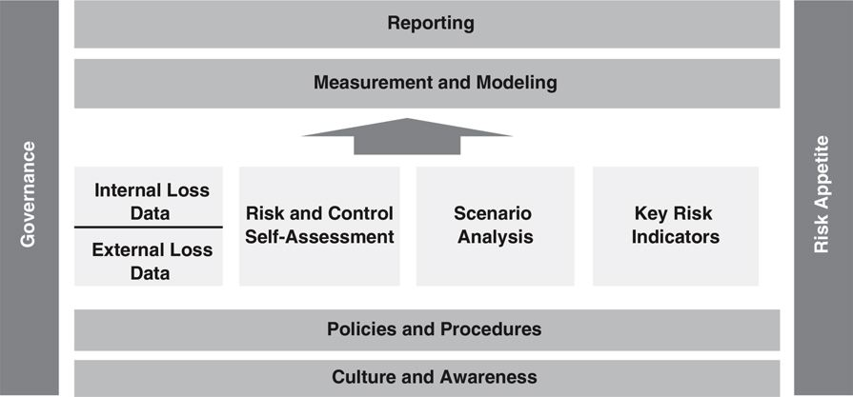
- foundations (that drive the design and acceptance of the operational risk framework as a whole)
  - governance
    - determines roles and responsibilities
      - head of the operational risk function
      - team that manages the framework
      - committees that oversee and make key decisions about risk management
      - operational risk managers in lines of business
      - every employee who may encounter operational risk
    - should be revisited at least annually, to check whether it is still working as intentioned
    - enables the escalation of risk
    - ensures that risk transparency is effective through all layers of operational risk management that may exist
    - holds the whole operational risk framework together
  - culture and awareness
    - requires winning over the hearts and minds of employees
    - spotting operational risks is a developed skill
    - takes the right tone, training, and awareness
  - policy and procedure
    - expected to have clear, actionable, and measurable policies and procedures
    - pay close attention to writing and actively managing policies and procedures
    - gives lines of business increased flexibility because the rules of the road are not ambiguous
    - increases autonomy when interacting with regulators
    - have well documented policies and procedures that reflect the requirements of each of the elements
  - risk appetite
    - holds the whole framework together
    - often takes time for an operational risk framework to mature to the stage where risk appetite can be effectively discussed and agreed upon
    - effective governance requires a clear articulation of risk appetite
- data elements (that are needed in order to have an effective operational risk framework)
  - loss data collection
    - internal loss data
      - occurs within the firm
      - data on events that have already occurred in the firm
      - Basel II requires a firm to have at least three years of internal loss data in order to pursue an advanced measurement approach
      - loss data collection needs to be quickly established, and carefully implemented to ensure good quality data is in place
    - external loss data
      - occurs outside the firm
      - events that have occurred in the industry (but outside the firm)
      - lessons learned from peers are valuable beyond regulatory requirements
      - help inform risk and control self-assessment and scenario analysis
        - often an important component in effective reporting
  - risk and control self-assessment
    - a view to controlling and mitigating any unacceptable risks
    - designed to help us to understand what risks we face today
      - looks at risk levels now
    - allows us to identify all risks, not just those that have already materialized
      - is about foresight
  - scenario analysis
    - looking for rare, catastrophic risks
    - focused on identifying plausible risks that are so large as to be potentially fatal or severely destructive to a firm
    - stresses the operational risk framework and pushes participants to think outside their comfort zone
    - requires participants to consider what could happen if there is a serious failure of controls or a previously unassessed combination of risks
  - key risk indicators
    - predicts that a risk is changing and would allow for proactive intervention
    - difficult to find metrics or combinations of metrics that are true key risk indicators
    - measuring an increase or decrease in risk levels
- outputs (that provide analysis & transparency)
  - measurement and modeling
    - advanced measurement approach capital calculation
      - requires four elements
        - internal loss data
        - external loss data
        - scenario analysis
        - business environment internal control factors
          - can be gathered from risk and control self-assessment and key risk indicators
  - reporting
    - gathers all of the information that has been collected and analyzed and puts it to use
    - quality of reporting is critical to the success of an operational risk framework
    - reporting that asks its audience to think or say or do something is of great value

Operational Risk Governance
- Role of Governance
  - provides oversight of operational risk management and measurement and to ensure an effective route for risk escalation
  - needs to reflect the culture of the firm and must be practical in nature
  - challenges
    - the sheer magnitude of the scope of coverage which touches virtually all activities and functions within an organization
    - operational risk management evaluates the outcomes and consequences of the organization's ability to perform and execute risk management activities as well as all other operations, controls and business functions on which the organization depends in order to remain viable
  - risk management and internal controls
    - should have a risk management function a compliance function and an internal audit function
      - each with sufficient authority, stature, independence, resources and access to the board
    - risks should be identified, assessed and monitored on an ongoing firm-wide and individual entity basis;
    - internal controls system which is effective in design and operation should be in place;
    - sophistication should keep pace with any changes to risk profile and external risk landscape
    - requires frank and timely internal communication about risk, both across the organization and through reporting to the board and senior management
  - roles in ensuring good governance
    - board of directors
      - establish, approve and periodically review the framework
      - oversee senior management to ensure that the policies, processes and systems are implemented effectively at all decision levels
      - approve and review a risk appetite and tolerance statement for operational risk that articulates the nature, types, and levels of operational risk that the bank is willing to assume
    - senior management
      - develop for approval by the board of directors a clear, effective and robust governance structure with well defined, transparent and consistent lines of responsibility
      - responsible for consistently implementing and maintaining throughout the organization policies, processes and systems for managing operational risk
- First Line of Defense
  - each business line
    - owns operational risk and should be managing it as it arises
    - responsible for identifying and managing the risks inherent in the products, activities, processes and systems for which it is accountable
  - person responsible for operational risk
    - business risk officer, nonfinancial risk officer, or operational risk manager
    - maintain independence from the business and so need to have a reporting line that is at the top of the organizational structure
  - there should be operational risk managers (or their equivalent) in operations, technology, finance, legal, compliance, and human resources as well as in any front office businesses
- Second Line of Defense
  - corporate operational risk function
    - responsible for the development of the operational risk framework and reporting on operational risk matters to the firm's senior management and board of directors
    - complements the business line's operational risk management activities
    - key function is to challenge the business lines' inputs to, and outputs from, the bank's risk management, risk measurement and reporting systems
    - should have a sufficient number of personnel skilled in the management of operational risk to effectively address its many responsibilities
  - Who Should Own the Operational Risk Function?
    - someone must be accountable for the success of the operational risk function
      - three critical qualities
        - independence
        - importance
        - relevance
    - Option 1: Operational Risk Is Owned by the Chief Risk Officer
      - most likely to be taken seriously by the rest of the organization
      - best demonstrates the seriousness and commitment of the operational risk function
      - best reflects the aspirations of many supervisory and regulatory bodies domestically and internationally
        - recommended by the Basel Committee on Banking Supervision
      - CRO should also report and have direct access to the board and its risk committee without impediment
      - CRO should not have any management or financial responsibility in respect of any operational business lines or revenue-generating functions
      - CRO should have the ability to influence decisions that affect the bank's exposure to risk
      - can help foster an environment where synergies between the risk categories can be identified and can provide the CRO with a more enterprise risk management view
      - disadvantages
        - operational risk can be overshadowed by market and credit risk
        - might create distance between operational risk and its related activities
    - Option 2: Operational Risk Is Owned by the Chief Operating Officer or the Chief Financial Officer
      - imbedded in day-to-day operations and therefore not as independent
      - increases opportunities to partner with other areas that own operational risks, such as legal and compliance, and the Sarbanes-Oxley team
      - raises the opportunity for governance, risk, and control (GRC) initiatives
      - disadvantages
        - may hinder the impartiality and objectivity of the operational risk department or at least tarnish the perception of its independence
        - limits the opportunities for strong partnership with the market and credit risk functions
    - Option 3: Operational Risk Is Owned by the Chief Compliance Officer
      - generally in smaller and less complex banks
      - clear opportunity to partner closely with the compliance department
        - leverage the reporting cycles, regular meetings, and existing assessment activities already in place
      - independence of the function can be well maintained
      - disadvantages
        - might be perceived to be out of touch with departments that do not usually interact with compliance
        - self-identification can be inconsistent with the way compliance departments function
        - might be viewed as a policing function
        - may be harder to demonstrate importance and relevance
        - partnerships with market and credit risk could be more challenging
  - What Should the Operational Risk Function Own?
    - Other Operational Risk Teams
      - each business unit and support function’s first line of defense
    - Embedded Operational Risk Coordinators or Specialists or Managers
      - should be a healthy and regular communication between the OR coordinator and the central operational risk team
    - Business Continuity Planning (BCP)
      - often focused on disaster recovery plans for technology systems
      - recently have expanded their role to cover other events that might disrupt the business
      - two particular Basel II categories
        - Damage to Physical Assets
        - Business Disruption and System Failures
    - Information Security
      - confidentiality, availability, and integrity of the firm's data
      - failure can result in a serious operational risk event
    - Sarbanes-Oxley Act
      - imposed operational risk management requirements regarding the accuracy of financial statements on U.S. publicly traded firms
    - New Business Approval or New Product Approval
      - new product programs include policies, procedures, and processes to assess and facilitate the review of new products or businesses before they are launched
      - provides a forum for discussions around the operational practicalities, accounting and tax practices, legal and regulatory requirements, and other areas
    - Policy Office
      - to centralize and standardize firm-wide policies
      - operational risk function will be designing, mandating, approving, and monitoring policies that manage operational risk
- Third Line of Defense
  - Audit
    - an independent review and challenge of the bank's operational risk management controls, processes and systems
      - may be done by audit or by staff independent of the process or system under review, but may also involve suitably qualified external parties
    - should be adequate to independently verify that the framework has been implemented as intended and is functioning effectively
    - should include opining on the overall appropriateness and adequacy of the framework and the associated governance processes across the bank
    - should be evaluating whether the Framework meets organizational needs and supervisory expectations
  - Validation and Verification
    - Validation
      - ensures that the operational risk measurement system is sufficiently robust and provides assurance of the integrity of inputs, assumptions, process and outputs
      - should provide enhanced assurance that the risk measurement methodology results in a credible estimate of operational risk capital that reflects the operational risk profile of the bank
      - not limited to quantitative aspects
        - covers validation of data inputs, methodology and use of outputs of operational risk models
    - Verification
      - performed on a periodic basis
      - typically conducted by the bank's internal and/or external audit, but may involve other suitably qualified independent parties from external sources
      - test the effectiveness of the overall ORMF, consistent with policies approved by the board of directors
      - test ORMS validation processes to ensure they are independent and are implemented in a manner consistent with established bank policies
  - Risk Committees
    - put in place for the escalation and management of operational risk
    - Committee structure
      - utilize a board-created enterprise level risk committee for overseeing all risks
      - operational risk managers report to committee
      - may receive input from operational risk committees by country, business or functional area.
      - may utilize a flatter organizational structure that oversees operational risk directly within the board's risk management committee;
    - Committee composition
      - include a combination of members with expertise in business activities and financial, as well as independent risk management
      - can include independent non-executive board members, which is a requirement in some jurisdictions
    - Committee operation
      - meetings should be held at appropriate frequencies with adequate time and resources to permit productive discussion and decision-making
      - records of operations should be adequate to permit review and evaluation of committee effectiveness

